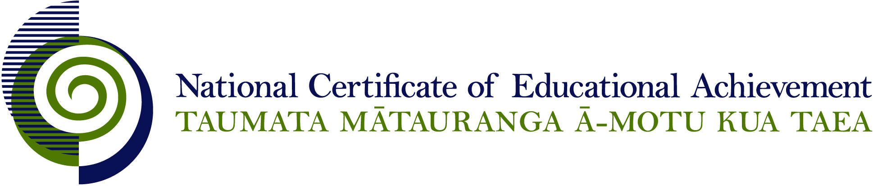

NCEA Level 2 Social Studies

Conditions of Assessment

General Information

Subject Reference | Social Studies
Domain | Social Studies
Level | 2

Conditions of Assessment

These Conditions provide guidelines for assessment against internally assessed Achievement Standards. Guidance is provided on:
- specific requirements for all assessments against this Standard
- appropriate ways of, and conditions for, gathering evidence
- ensuring that evidence is authentic.

Assessors must be familiar with guidance on assessment practice in learning centres, including enforcing timeframes and deadlines. The NZQA website offers resources that would be useful to read in conjunction with these Conditions of Assessment.

The learning centre’s Assessment Policy and Conditions of Assessment must be consistent with NZQA’s Assessment Rules for Schools with Consent to Assess. This link includes guidance for managing internal moderation and the collection of evidence.

Gathering Evidence

Internal assessment provides considerable flexibility in the collection of evidence. Evidence can be collected in different ways to suit a range of teaching and learning styles, and a range of contexts of teaching and learning. Care needs to be taken to allow students opportunities to present their best evidence against the Standard(s) that are free from unnecessary constraints.

It is recommended that the design of assessment reflects and reinforces the ways students have been learning. Collection of evidence for the internally assessed Standards could include, but is not restricted to, an extended task, an investigation, digital evidence (such as recorded interviews, blogs, photographs, or film), or a portfolio of evidence.

Effective assessment should suit the nature of the learning being assessed, provide opportunities to meet the diverse needs of all students, and be valid and fair.

Ensuring Authenticity of Evidence

Authenticity of student evidence needs to be assured regardless of the method of collecting evidence. This must be in line with the learning centre’s policy and NZQA’s Assessment Rules for Schools with Consent to Assess.

Ensure that the student’s evidence is individually identifiable and represents the student’s own work. The evidence must be an accurate reflection of what the student independently knows and can do, according to the Standard being assessed. This includes evidence submitted as part of a group assessment, evidence produced outside of class time or without assessor supervision, and evidence produced with any use of generative artificial intelligence tools (GenAI). GenAI use should be carefully considered in the context of the Standard being assessed and its Conditions of Assessment, discussed with students before the assessment, and its use must be acknowledged. For example, an investigation carried out over several sessions could include:
- teacher guidance on the nature and extent of acceptable GenAI use, if any
- assessor observations and conversations
- meeting with the student at set milestones or checkpoints
- the student’s record of progress, such as photographic entries or any GenAI prompts used.

Specific Information for Individual Internal Achievement Standards

Achievement Standard Number | 91280 Social Studies 2.2
Title | Conduct a reflective social inquiry
Number of Credits | 5
Version | 3

The focus of the enquiry may be provided by the teacher or selected by the student. Templates may be provided by teachers. Questions should be written by the student.

Evidence for this achievement standard would be expected to be gathered from in and out of class activities to be completed by students over a period of time specified by the teacher. This evidence may be generated from discussion, group work, research, decision making and/or reflection and will be presented in any media that clearly communicates the student’s understanding of the investigation. Where a group approach is used the teacher needs to ensure that there is evidence that each student has met all aspects of the standard.

Achievement Standard Number | 91282 Social Studies 2.4
Title | Describe personal involvement in a social action related to rights and responsibilities
Number of Credits | 5
Version | 2

Planning for a social action can be done within a group. Where a group approach is used the teacher needs to ensure that there is evidence that each student has met all aspects of the standard.

A social action is an action which has been set up within an agreed framework that has been negotiated with the assessing school. It could include working with community groups, regional, national organisations, or NGOs and so on. The action will encourage active participation by members.

The personal involvement should be based on negotiated participation in an action approved by the assessing school.

Personal involvement means actively participating in a social action. It is recommended that evidence of participation is recorded. This record could be presented in a range of media (for example a written or visual log or in a portfolio format). A portfolio could include a variety of media (for example, written notes, annotations, blog entries, video, graphics, photographs, podcasts, interactive mindmaps and other online presentations) in any format.

The record should contain specific examples of how the student has participated in the social action.

Organisations and groups involved could provide resource support and logistic support.

A plan can be based upon an existing framework.

Achievement Standard Number | 91283 Social Studies 2.5
Title | Describe a social action that enables communities and/or nations to meet responsibilities and exercise rights
Number of Credits | 4
Version | 2

The social action used in this Achievement Standard is intended to be different from the social action used by a student as a basis for assessment in AS 2.4.

Evidence for this achievement standard would be expected to be gathered from in and out of class activities to be completed by students over a period of time specified by the teacher. This evidence may be generated from discussion, group work, research, decision making and/or reflection and will be presented in any media that clearly communicates the student’s understanding of the investigation. Where a group approach is used the teacher needs to ensure that there is evidence that each student has met all aspects of the standard.

